Problem 1:
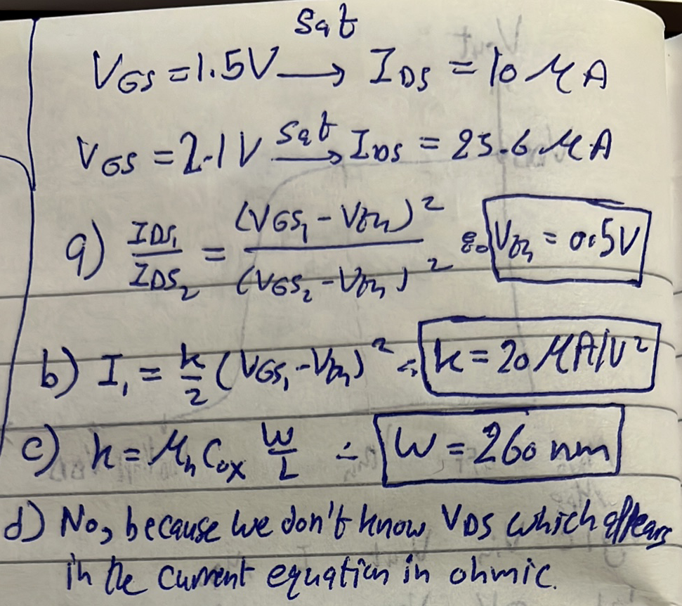
Problem 2:
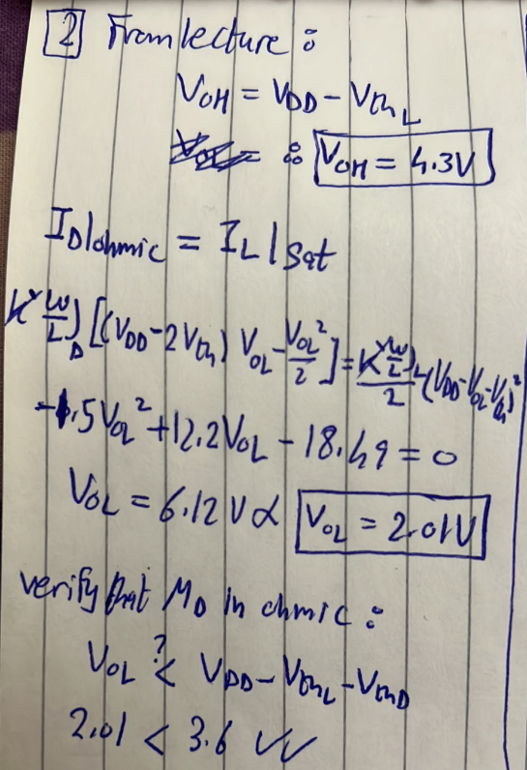
c) Increasing ${\left(\frac{W}{L}\right)}_{D}$will not affect $V_{OH}$ because the driver is cut-off. However, in case of $V_{OL}$, increasing ${\left(\frac{W}{L}\right)}_{D}$ will decrease the driver’s resistance (remember: $R_{ON_{MOSFET}}=\frac{1}{K\left(V_{GS}-V_{TH}\right)}$) and hence $V_{OL}$ will decrease.

Problem 3.
